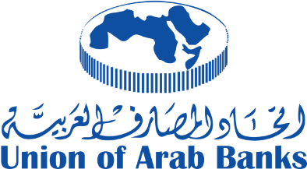 | 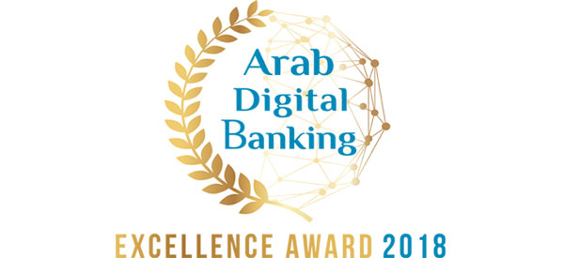

Arab Digital Banks Excellence Award - 2018

Participation/Registration Form
Deadline: the 15th of February 2019

Participant’s information:
Name of the Bank: …………………………………………………………………………………….
Department: …………………………………………………………………..………………..……….
Website of the Bank: …………………………………………………………………………………
Name of the person (applicant) ……………………….……………………………………………
Job title ………………………………………………………………………….…………………………
Postal address …………………………………………………………………………………………
Phone number(s) ……………………………………………………………….…………………
E-mail address ……………………………………………………………….…………………

Award categories:
- Award of the Best Digital Bank in the Arab region
- Award for the best Digital Service
- Award of best Mobile Banking Application
- Award for the best Banking Website
- Award for the “Digital Financial Inclusion”

Candidates could apply for more than one category of the Awards.

Information about the project:
- Please mention any other entities/parties that participated in the implementation of this project (eg, banks, technology consulting companies, Fintech companies)
- Please provide a brief description of the project (250 words maximum)
- Please indicate the main dates of phases of the project (Date/duration of preparation, date of implementation and date of the launching of the project)
- project characteristics: What makes it unique or different from the similar solutions or products (500 words maximum)
- What are the benefits resulting from implementing this service? mention the main achievements and main objectives, what is the extent of the use of this service? And the benefit of customers in terms of cost reduction or time and effort saving, or effort on (Max 500 words)
- What was your customers /users feedback of your product? Share with us at least 10 of your customer reviews

Signature

Registration fees:
- 3000 USD for one category of the Award
- 5000 USD for two categories of the Award
- 7.000 USD for three categories of the Award
- 9.000 USD for four categories of the Award
- 11.000 USD for five categories of the Award

Bank Transfer information:
The participation fees are to be transferred to the account of the Arab Information and Communication Technologies Organization as following:
American Dollar Account :
Account name: Arab Digital Banks Excellence Award
Arab Bank - Beirut - Lebanon
Swift code: ARABLBBX
Account no: 0331 082305 -810
Iban no: LB90 0005 0000 0000 3310 8230 5810
Through Wells Fargo Bank, N.A, San Francisco, CA, USA
Swift code: WFBIUS6S
Beneficiary name: Union of Arab Banks

Please do not mention any confidential information about your project or service, as the information provided will be included in the winners’ announcement

Thank you for participating in the “Arab Digital Financial Excellence Award – 2018”.
_____________________________________________________________________________________

Please send this registration form by e-mail to: awards2018@adb-awards.org no later than the 15th of February 2019 with the proof of the bank transfer.

If you would like to share more information, you have to send it in a separate document enclosed to the form.

