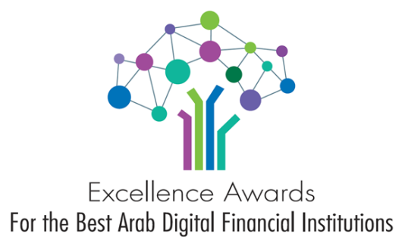
____________________________________________________
Excellence Awards
For the Best Arab Digital Financial Institutions - 2020
Participation/Registration Form (Banks)
Registration deadline: 31 March 2021
Participant’s information:
Name of the Bank: ……………………………………………………………………………………………………………….
Department: …………………………………………………………………..………………………….
Website of the Bank: ………………………………………………………………………………………………………….……
Name of the person (applicant) ……………………….……………………………..………………
Job title ………………………………………………………………………….…………………………
Postal address …………………………………………………………………………………………
Phone number(s) …………………………………………………………………….…………………
E-mail address ………………………………………………………………………….…………………
Award categories:
Categoy 1 : Best Digital Banks
C1-1 : Best Digital Bank in the Arab Region
C1-2 G: Best Digital Bank in the Gulf Region
INNOVATION | INCLUSIVENESS | LOYALTY | WELLBEING
C1-2 ME : Best Digital Bank in the Middle East
INNOVATION | INCLUSIVENESS | LOYALTY | WELLBEING
C1-2 NA:Best Digital Bank in the North Africa
INNOVATION | INCLUSIVENESS | LOYALTY | WELLBEING
C1-3: Best Digital Bank (in each country)
INNOVATION | INCLUSIVENESS | LOYALTY | WELLBEING

Date : …………………..

Signature & Seal : ……………………..

Requested Information:
The inputs from participants should be in accordance with the assessment criteria mentioned in the Award Brochure and in the website of the Award and through answering the following main questions:
- The capacity of the digital strategy of the bank or Post to polarize and serve the digital customers
- Widening of the range of the digital services and products provided/offered by the bank : List of the digital services | Description | Date of launching | Users number | The extent to which these digital services meet the needs of the Bank customers
- The success in driving customers towards the digital offers | Growth in the number of digital customers during the last 3 years
- Customers benefits from the digital initiatives | Benefits given by the financial institutions through digital initiatives
- Achievement of the “Financial Inclusion” and the “Digital Financial Inclusion”
- Contribution of the applications and platforms in the access of citizens/users to digital financial services (especially in rural / isolated areas)
- Communication plan : the possibilities and facilities provided by the banks or postal institutions in their direct relationships with customers
- Is there a dedicated Technological Strategy to achieve the “Digital Financial Inclusion”?
- Is there any specific measures taken by the financial institution to move towards the digital alternative in the response of COVID-19 requirements? What kind of measures? How responsive was the financial institution to cope with the social distancing measures?
- What special measures have been set up to reassure customers, so to trust online financial transactions during the pandemic period?
- Details about the customer experience through testimonials and surveys provided by the financial institution
(More details about the assessment criteria will be found in the Award Brochure. Highly rated financial institutions will be those who provide as much as information in accordance with the four main pillars of the Award : Innovation – Inclusion – Loyalty – Wellbeing).

Registration fees:
Categories | Registration fees
- C1-1 : Best Digital Bank in the Arab Region | For registration fees, please contact : awards2020@adb-awards.org
- C1-2 G: Best Digital Bank in the Gulf Region
(INNOVATION – INCLUSIVENESS – LOYALTY – WELLBEING)
- C1-2 ME : Best Digital Bank in the Middle East
(INNOVATION – INCLUSIVENESS – LOYALTY – WELLBEING)
- C1-2 NA: Best Digital Bank in the North Africa
(INNOVATION – INCLUSIVENESS – LOYALTY – WELLBEING)
- C1-3: Best Digital Bank (in each country)
(INNOVATION – INCLUSIVENESS – LOYALTY – WELLBEING)

- All participants in the C1-1 category, will be automatically nominees for one of the regional and local categories upon their choices (INNOVATION /or/ INCLUSIVENESS /or/ LOYALTY /or/ WELLBEING).
- Banks who participate in the second category (C1-2 G, C1-2 ME, C1-2 NA) will be automatically registered to compete for one of the third category (C1-3: Best Digital Bank (in each country) )
(INNOVATION /or/ INCLUSIVENESS /or/ LOYALTY /or/ WELLBEING)

Bank Transfer information:
The participation fees are to be transferred to the following account :
American Dollar Account :

Account name : Union of Arab Banks - Excellence Awards
Bank name : Arab Bank – Amman – Jordan
Shmeisani Branch
Account no: 0118/010272-5/514
Iban no : JO65 ARAB 1180 0000 0011 8010 2725 14
Swift code : ARABJOAX118
Beneficiary name : Union of Arab Banks

Please do not mention any confidential information about your project or service, as the information provided will be included in the winners’ announcement

Thank you for participating in the “Excellence Awards for the Best Arab Digital Financial Institutions – 2020
________________________________________________________

Please send this Registration Form by e-mail to: awards2020@adb-awards.org no later than the 31st of March 2021 with the proof of the bank transfer.

If you would like to share more information, you have to send it in a separate document enclosed to the form.
Please do not hesitate to contact us for any further information you may need.

